

COURSE: | ARTIFICIAL INTELLIGENCE
LAB: | #1
NAME: | MUZAMMIL BIN SOHAIL
ROLL NO.: | 22F - 3110
DEGREE: | BS - AI
SECTION: | 4A1

Question 1:
(ADJACENCY MATRIX)
Some Screenshots:
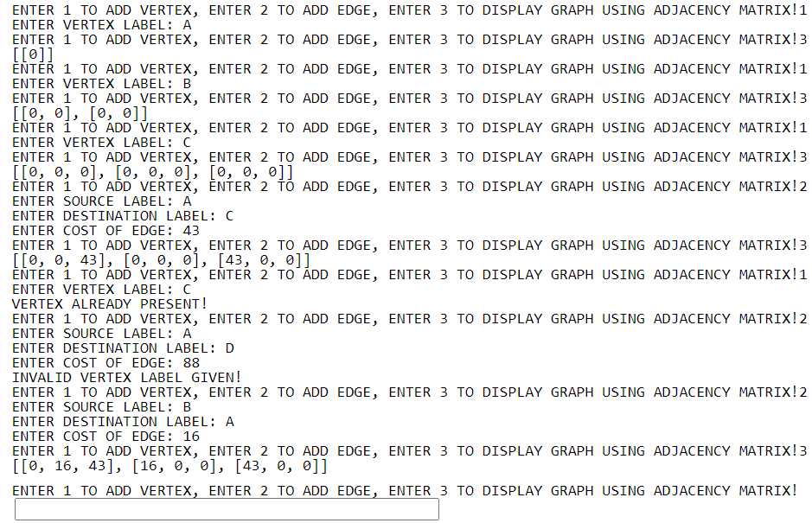
Code:
#ADJACENCY MATRIX
def addVertex(v):
global graph
global vCount
graph2 = []
for i in range(0,vCount):
graph2.append([])
for j in range(0,vCount):
graph2[i].append(0)

for i in range(0,vCount-1):
for j in range(0, vCount-1):
graph2[i][j] = graph[i][j]

graph = graph2

def addEdge(s,d,c):
global vLabels
source = 0
for i in range(0, len(vLabels)):
if s == vLabels[i]:
source = i

if d == vLabels[i]:
destination = i

graph[source][destination] = c

def display(graph):
print(graph)

if __name__ == '__main__':
graph = []
vCount = 0
vLabels = []
option = 0
end = False
while(end != True):
option = int(input("ENTER 1 TO ADD VERTEX, ENTER 2 TO ADD EDGE, ENTER 3 TO DISPLAY GRAPH USING ADJACENCY MATRIX, ENTER 4 TO EXIT THE PROGRAM!"))

if(option == 1):
v = input("ENTER VERTEX LABEL: ")
if v not in vLabels:
vLabels.append(v)
vCount = vCount + 1
addVertex(v)

else:
print("VERTEX ALREADY PRESENT!")
elif(option == 2):
s = input("ENTER SOURCE LABEL: ")
d = input("ENTER DESTINATION LABEL: ")
c = int(input("ENTER COST OF EDGE: "))

if s in vLabels and d in vLabels:
addEdge(s,d,c)
addEdge(d,s,c)

else:
print("INVALID VERTEX LABEL GIVEN!")

elif(option == 3):
display(graph)

elif(option == 4):
end == True

else:
print("INVALID INPUT!")

